Auditing Pretraining Contamination in 3D Brain-MRI Foundation Models Using a Same-Scanner Natural Experiment
Pranav PN  School of Computer Science and Engineering  Vellore Institute of Technology  Chennai, India  pranav.pn2024@vitstudent.ac.in | Shiva Somesh S  School of Computer Science and Engineering  Vellore Institute of Technology  Chennai, India  shivasomesh.s@vitstudent.ac.in

ABSTRACT Brain-MRI foundation models are said to work best when labeled data are scarce. The catch is that their pretraining collections include public cohorts that double as benchmarks, so the subjects used for evaluation may already have passed through the encoder. This study presents a pre-registered, contamination-audited framework that measures how much of a foundation model's advantage depends on that exposure. A subject-level audit intersects each evaluation cohort with the pretraining manifests and labels it seen or unseen. A natural experiment on the Amsterdam Open MRI Collection then contrasts one cohort included in pretraining (ID1000) with two that were excluded from it (PIOP1 and PIOP2); the pre-registration describes all three as acquired on the same 3T scanner. The primary statistic is a difference-in-differences of brain-age error between foundation models and tuned supervised baselines, tested with 2,000 bootstrap resamples. BrainIAC and FOMO25 checkpoints are adapted at four tiers, running from a linear probe up to full fine-tuning, and are compared with ResNet-18, DenseNet-121 and LightGBM-on-regional-volumes baselines. All arms get matched label budgets and matched Optuna tuning budgets, and GPU-seconds are logged. Secondary analyses look at label equivalence, compute-matched Pareto frontiers and rank stability across five seeds. Hypotheses, controls, reporting tables and decision rules are fixed before any result is read, and the threats to validity that the design cannot remove are stated openly.
INDEX TERMS: Brain MRI, Foundation Models, Data Contamination, Self-Supervised Learning, Difference-in-Differences, Label Efficiency, Brain-Age Prediction, AOMIC, Benchmark Reproducibility
I. LITERATURE SURVEY
PAPER 1:
A generalizable foundation model for analysis of human brain MRI
Nature Neuroscience, 2026 (published as “A foundation model for generalized brain MRI analysis”)
This paper introduces BrainIAC, a self-supervised brain-MRI foundation model, and tests how well its learned features carry over to a range of clinical prediction and imaging tasks. Instead of training a new network on labeled examples for every task, the authors pretrain an encoder without labels and then reuse it, so that a single representation has to serve problems that differ in target, population and imaging protocol.
Its central claim is generalisability: one pretrained model should stay useful when it is moved to a new task.
Relevance to this work: BrainIAC is one of the two foundation models evaluated in this project. Its value rests on transfer to downstream cohorts, so its benchmark results depend directly on whether the evaluation subjects were part of pretraining.
Link: https://doi.org/10.1038/s41593-026-02202-6
PAPER 2:
Towards Brain MRI Foundation Models for the Clinic: Findings from the FOMO25 Challenge
arXiv preprint, 2026
This paper reports the findings of the FOMO25 challenge, which compared brain-MRI foundation models on few-shot clinical tasks and on out-of-domain MRI. It shows how pretraining choices affect performance when the test data differ from the pretraining data, which puts domain shift at the center of any clinical use of these models.
Putting different models under the same evaluation conditions gives a kind of controlled comparison that independently published results rarely allow.
Relevance to this work: The FOMO25 checkpoints are the second foundation-model family evaluated here, and the challenge's focus on few-shot settings motivates the label-budget sweep (N = 25 to all) used in this study.
Link: https://arxiv.org/abs/2604.11679
PAPER 3:
A large-scale heterogeneous 3D magnetic resonance brain imaging dataset for self-supervised learning
arXiv preprint, 2025
This paper describes FOMO60K, a large and varied collection of 3D brain MRI assembled for self-supervised learning. The scans come from many sources, and the release ships with source and participant metadata, so it is possible to check which cohorts overlap with a given benchmark.
The authors present heterogeneity across scanners, protocols and populations as the main strength of the collection for pretraining.
Relevance to this work: The collection's metadata files (mapping.tsv and participants.tsv) serve as the pretraining manifests against which subject identifiers are intersected in the contamination audit.
Link: https://arxiv.org/abs/2506.14432
PAPER 4:
BrainSegFounder: Towards 3D foundation models for neuroimage segmentation
Medical Image Analysis, 2024
This paper introduces a self-supervised 3D brain-MRI model for multimodal neuroimage segmentation and evaluates it on tumor and stroke-lesion tasks. Pretraining in 3D on multimodal MRI is aimed at segmentation problems where expert-labeled volumes are expensive to get.
In effect, it carries the foundation-model idea over from classification and regression to dense prediction.
Relevance to this work: Segmentation foundation models are also pretrained on large pooled collections, so the same subject-level audit logic applies to them, even though this project evaluates regression.
Link: https://arxiv.org/abs/2406.10395
PAPER 5:
Towards Generalisable Foundation Models for 3D Brain MRI
arXiv preprint, 2025
This paper introduces BrainFound, which adapts DINOv2-style self-supervised learning to 3D brain MRI and examines how the learned representation transfers across imaging protocols and downstream tasks.
The property under study is robustness to a change in acquisition protocol.
Relevance to this work: The same-scanner design of this project deliberately holds protocol robustness fixed, so any seen-versus-unseen gap cannot be blamed on a protocol change.
Link: https://arxiv.org/abs/2510.23415
PAPER 6:
Evaluating the Generalization of Neuroimaging Foundation Models on African Brain MRI
arXiv preprint, 2026
This paper tests recent neuroimaging foundation models on a Nigerian clinical cohort and points to limits in how well such models transfer to underrepresented populations.
It is one example of evaluating a pretrained model on a cohort that differs from the pretraining population in several ways at once.
Relevance to this work: Switching cohorts changes population, scanner and protocol together, which is why this work tries to isolate pretraining exposure from the other sources of shift.
Link: https://arxiv.org/abs/2609.23983
PAPER 7:
Data leakage inflates prediction performance in connectome-based machine-learning models
Nature Communications, 2024
This paper studies leakage across neuroimaging prediction pipelines and shows that repeated subjects and other forms of leakage can inflate the reported performance of connectome-based machine-learning models.
Its argument is that seemingly small pipeline decisions can change the headline accuracy of a study.
Relevance to this work: Pretraining overlap is one more route to the same problem, and a subject-level split of the downstream data does not remove it. The audit and frozen splits in this project take on the lesson that subject identity has to be tracked end to end.
Link: https://doi.org/10.1038/s41467-024-46150-w
PAPER 8:
Removing the effects of the site in brain imaging machine-learning – Measurement and extendable benchmark
NeuroImage, 2023
This paper benchmarks scanner and site effects in multisite brain imaging and evaluates how different harmonization methods influence machine-learning results.
Because the benchmark is extendable, new harmonization methods can be compared on equal footing.
Relevance to this work: Site effects can pass for model differences. That is why the natural experiment in this project uses cohorts that the pre-registration describes as acquired on one scanner.
Link: https://doaj.org/article/b6e86200f19e41a58ad8d0c2ad13c695
PAPER 9:
Membership Inference Attacks on Deep Regression Models for Neuroimaging
Medical Imaging with Deep Learning (MIDL), PMLR 143, 2021
This paper shows that model outputs or parameters can reveal whether an individual's MRI was used during training, even when the raw scans are never shared.
The attacks target deep regression models, which is the same model class used for brain-age prediction.
Relevance to this work: Trained networks hold on to information about individual training scans, so exposure to a test subject during pretraining is not a harmless detail. Membership inference is a candidate independent check for future work.
Link: https://arxiv.org/abs/2105.02866
PAPER 10:
Privacy-preserving Federated Brain Tumour Segmentation
Machine Learning in Medical Imaging (MLMI), 2019
This paper studies privacy-preserving federated learning for brain tumor segmentation, and the trade-off between protecting privacy and keeping model performance.
The setting of interest is training across institutions without sharing raw data.
Relevance to this work: Multi-site training pools rely on participant-level provenance records, and those are the same records an overlap audit needs in order to work.
Link: https://arxiv.org/abs/1910.00962
Table 1: Comparative Analysis of Recent Publications on Brain-MRI Foundation Models, Generalization, Leakage and Privacy
REFERENCE | DATASET | METHODOLOGY | APPLICATION | ADVANTAGE | LIMITATION
BrainIAC [1] (Nat. Neurosci., 2026) | Multiple brain-MRI cohorts spanning several clinical tasks | Self-supervised pretraining; feature transfer | Clinical prediction and imaging tasks | One encoder reused across tasks | Exposure of benchmark subjects to pretraining must be verified
FOMO25 Challenge [2] (arXiv, 2026) | Few-shot clinical tasks; out-of-domain MRI | Challenge comparison of foundation models | Few-shot clinical tasks under domain shift | Same conditions for all models | Not a seen-versus-unseen contrast
FOMO60K [3] (arXiv, 2025) | FOMO60K: large heterogeneous 3D brain MRI | Dataset curation with source and participant metadata | Self-supervised pretraining | Metadata allows overlap checks | Overlap with benchmarks must be checked
BrainSegFounder [4] (Med. Image Anal., 2024) | Multimodal MRI; tumor and stroke lesion tasks | Self-supervised 3D pretraining | Neuroimage segmentation | Dense-prediction transfer | Segmentation focus; overlap audit out of scope
BrainFound [5] (arXiv, 2025) | Brain MRI across imaging protocols | DINOv2-style 3D learning | Cross-protocol, cross-task transfer | Protocol robustness studied | Same-scanner exposure contrast not studied
African Brain MRI Evaluation [6] (arXiv, 2026) | Nigerian clinical MRI cohort | Zero-shot and transfer testing of foundation models | Population-shift evaluation | Tests an underrepresented population | Single clinical cohort
Leakage in Connectome ML [7] (Nat. Commun., 2024) | Neuroimaging prediction pipelines | Controlled comparison of leakage types | Evaluation validity | Quantifies performance inflation | Connectome models, not MRI foundation models
Site-Effect Benchmark [8] (NeuroImage, 2023) | Multisite brain imaging | Harmonization benchmark | Scanner and site effect removal | Extendable benchmark | Does not address pretraining exposure
Membership Inference on Neuroimaging [9] (MIDL, 2021) | Neuroimaging regression models | Membership inference attacks | Privacy auditing | Shows membership can be detected | Needs model outputs or parameters
Federated Tumour Segmentation [10] (MLMI, 2019) | Multi-institution brain tumor MRI | Privacy-preserving federated learning | Multi-site training | Privacy and performance trade-off studied | Tumor segmentation task only

II. PROPOSED METHODOLOGY
The framework proposed here is a computer-aided evaluation protocol. It measures how much of a brain-MRI foundation model's reported advantage can be attributed to pretraining exposure to the evaluation subjects. The literature reviewed (see Table 1) treats the pieces separately: foundation models are evaluated on downstream tasks [1]–[5], transfer to new populations and sites is studied in [6], [8], and leakage [7] and membership leakage [9] are documented on their own. Across these ten works, none combines a subject-level audit of pretraining overlap with a seen-versus-unseen contrast on a single scanner, evaluated against tuned supervised baselines under matched label and tuning budgets.
The protocol is pre-registered, and its cohorts come from the Amsterdam Open MRI Collection (AOMIC) [11]. Each foundation model gets three outputs: 1) an overlap percentage for every benchmark cohort; 2) a difference-in-differences estimate of the seen-versus-unseen error penalty; and 3) label-equivalence and compute-matched comparisons against supervised baselines.
We organise the framework into five modules. Module 1 audits subject overlap between the evaluation cohorts and the pretraining manifests. Module 2 builds frozen, stratified splits and applies one shared preprocessing pipeline. Module 3 defines the model arms, including a four-tier adaptation ladder for each foundation model. Module 4 fits all arms under matched label and tuning budgets, with GPU-second accounting. Module 5 computes every statistic from a single append-only ledger. Figure 1 shows the architecture of the system.
ResNet-18 is a residual convolutional network. Its skip connections let information pass directly between layers, which makes deeper networks easier to train [13]. We train a 3D ResNet-18 from MONAI [12] from scratch on the preprocessed volumes and use it as the compact supervised baseline.
DenseNet-121 connects each layer to all the layers before it within a dense block. This encourages feature reuse and keeps the parameter count low [14]. The MONAI 3D implementation [12] serves as our second supervised baseline.
The volumetric baseline drops learned image features and uses regional brain volumes instead, fitting a LightGBM gradient-boosted tree model [15] to them. It is cheap to run, and it tests whether a classical, interpretable pipeline already captures what the foundation models offer.
BrainIAC [1] and the FOMO25 checkpoints [2] are self-supervised foundation models, and their encoders are reused by attaching a task head. Each is adapted at four tiers of increasing capacity, from a frozen encoder with a linear probe up to full fine-tuning.
In this project we experiment with ResNet-18, DenseNet-121, the volumetric LightGBM model, and BrainIAC and FOMO25 at four adaptation tiers each. We compare their errors on seen and unseen cohorts, their label equivalence and their compute cost. The conclusion then comes from the pre-specified decision rules in Table X, not from whichever comparison looks most favourable.
Figure 1: System architecture of the contamination-audited evaluation framework.
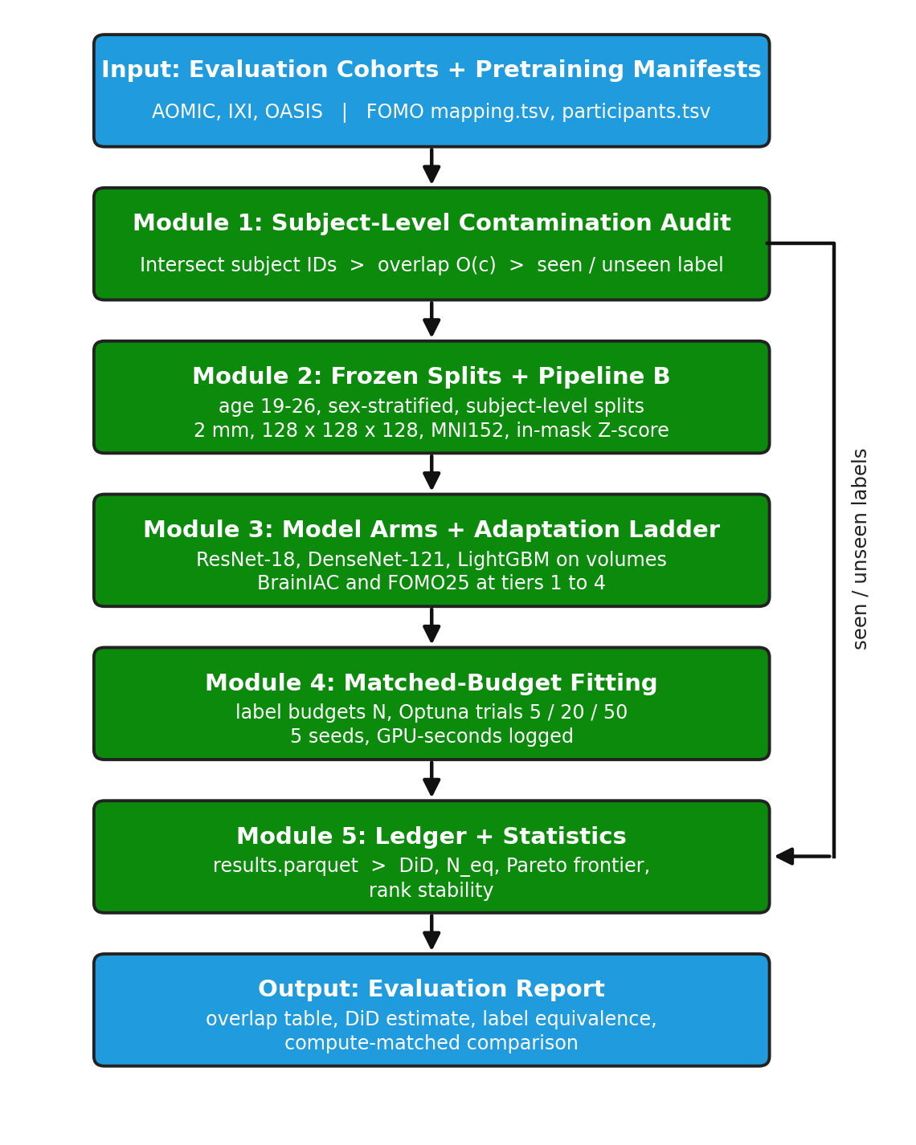

III. MODULE DESCRIPTION
MODULE 1: Subject-Level Contamination Audit
The first module works out which evaluation subjects the foundation models may already have seen. It matches subject identifiers, not scans. For a cohort c with subject-ID set S_c and a pretraining manifest with subject-ID set P, the overlap is given in Equation 1. Since matching is at subject level, a different session or modality of a pretraining subject still counts as seen.
Eq. 1 — Subject-level overlap:
$$O\left(c\right)=\frac{\left|S_{c}∩P\right|}{\left|S_{c}\right|}×100\%$$
The audit suite has three steps. fetch_manifests.py downloads the FOMO manifest files (mapping.tsv and participants.tsv), overlap.py matches identifiers across cohorts, and report_contamination.py renders the overlap table and figures from a cohort list (audit_cohorts.json). Each cohort then gets a status according to Equation 2, where τ_hi and τ_lo are thresholds chosen before any model is evaluated. A cohort that falls between the two thresholds is reported, but it is left out of the seen-versus-unseen contrast.
Eq. 2 — Cohort status:
$$status\left(c\right)=\left\{\begin{matrix}\text{seen} & O\left(c\right)≥τ_{hi} \\ \text{unseen} & O\left(c\right)≤τ_{lo} \\ \text{excluded} & \text{otherwise}\end{matrix}\right.$$
MODULE 2: Natural Experiment, Splits and Preprocessing
The second module builds the controlled contrast. The pre-registration identifies AOMIC ID1000 as part of the pretraining data (seen) and AOMIC PIOP1 and PIOP2 as excluded (unseen). It describes all three as healthy young adults scanned on the same Philips Achieva 3T at the University of Amsterdam with an identical protocol [11]. Holding scanner and protocol constant is what lets the contrast separate pretraining exposure from site effects [8].
Four controls are mandatory. Both cohorts are restricted to the overlapping age window of 19.0 to 26.0 years, and evaluation splits are stratified by sex and by the age histogram, as in Equation 5. No subject or longitudinal session may appear in both training and validation or test splits. The splits are also frozen before any training.
All arms share one preprocessing pipeline, Pipeline B. Volumes are resampled to 2 mm isotropic resolution on a 128 × 128 × 128 grid in MNI152 space with RAS orientation (Equation 3). Intensities are normalised within the brain mask M using the mean μ_M and standard deviation σ_M of the in-mask voxels (Equation 4), and the volumes are cached as float16 arrays. Template registration is a documented upstream step. A slice-montage generator logs every QC exclusion.
Eq. 3 — Resampling:
$$I_{r}=Resample\left(I, 2 mm, 128×128×128\right)$$
Eq. 4 — In-mask Z-score normalization:
$$I_{z}\left(v\right)=\frac{I_{r}\left(v\right)-μ_{M}}{σ_{M}}, v∈M$$
Eq. 5 — Age-restricted stratified split:
$$\left(D_{train}, D_{val}, D_{test}\right)=StratifiedSplit\left(\{x_{i}:19.0≤a_{i}≤26.0\}, strata=\left(bin\left(a_{i}\right), s_{i}\right)\right)$$
MODULE 3: Model Arms and the Adaptation Ladder
The third module defines the models. Every arm is an encoder f_θ followed by a head g_φ, as in Equation 6. All arms implement a single interface, ModelArm, with fit(loader, budget) and predict(loader), which means the harness treats a linear probe and a full network in exactly the same way. Table 2 lists the arms.
Eq. 6 — Encoder and head:
$$\hat{y}=g_{ϕ}\left(f_{θ}\left(x\right)\right)$$
The adaptation ladder (Figure 2) gives each foundation model four tiers. Tier 1 freezes the encoder and trains a linear probe (Equation 7). Tier 2 also freezes the encoder but trains a two-layer MLP head (Equation 8). Tier 3 additionally trains the last encoder block, and Tier 4 trains all weights.
Eq. 7 — Tier 1, linear probe:
$${\hat{y}}_{tier 1}=w^{⊤}f_{θ}\left(x\right)+b, θ frozen$$
Eq. 8 — Tier 2, MLP head:
$${\hat{y}}_{tier 2}=W_{2} σ\left(W_{1}f_{θ}\left(x\right)+b_{1}\right)+b_{2}, σ\left(z\right)=max\left(0,z\right)$$
Table 2: Model Arms and Tuning Budgets
Arm | Family | Trainable | Trials
ResNet-18 (MONAI) | Supervised, scratch | All weights | 5, 20, 50
DenseNet-121 (MONAI) | Supervised, scratch | All weights | 5, 20, 50
Volumetric + LightGBM | Tabular | Boosted trees | 5, 20, 50
BrainIAC, tiers 1–4 | Foundation model | Head, last block or all | 5, 20, 50
FOMO25, tiers 1–4 | Foundation model | Head, last block or all | 5, 20, 50

Figure 2: The four-tier adaptation ladder.
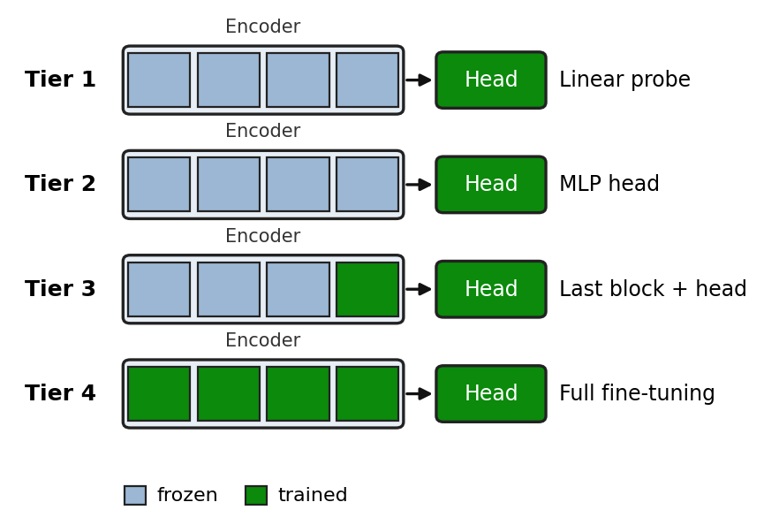
MODULE 4: Matched-Budget Fitting
The fourth module is there to make sure no arm gets an edge from extra effort. Models are fitted to minimise the mean absolute error of Equation 9, which is the same quantity as the primary metric. Label budgets are N in {25, 50, 100, 250, 500, all}. Baselines and foundation-model heads get identical Optuna [16] budgets of 5, 20 and 50 trials over identical search spaces, and the configuration is chosen on validation error alone (Equation 10).
Eq. 9 — Training loss:
$$L\left(θ,ϕ\right)=\frac{1}{n}\sum_{i=1}^{n}{\left|y_{i}-{\hat{y}}_{i}\right|}$$
Eq. 10 — Hyperparameter selection:
$$λ^{*}=arg\min_{λ∈Λ_{T}} {MAE}_{val}\left(λ\right), T∈\{5,20,50\}$$
We log compute in GPU-seconds, counting preprocessing, tuning, training and inference (Equation 11). Every (task, model, N) cell is run with five seeds: 42, 1337, 2026, 7 and 99. Test sets stay quarantined, and each selected model is evaluated just once, at benchmark freeze.
Eq. 11 — Total compute:
$$C=C_{prep}+C_{tune}+C_{train}+C_{infer}$$
MODULE 5: Statistical Analysis
The fifth module turns the ledger into evidence. For a model m, the seen-to-unseen error gap is given in Equation 12. The primary statistic is the difference-in-differences [17] between a foundation model (FM) and a supervised baseline (Equation 13). Whatever shift a from-scratch model suffers between the two cohorts is absorbed in the baseline's gap, so a positive value is the excess penalty borne by the foundation model.
Eq. 12 — Seen-to-unseen error gap:
$$Δ_{m}={MAE}_{m,unseen}-{MAE}_{m,seen}$$
Eq. 13 — Difference-in-differences:
$$DiD=Δ_{FM}-Δ_{base}$$
The pre-registered hypotheses are H1 (contamination), DiD > 0 with p < 0.05 under a two-tailed bootstrap test with 2,000 resamples, and H0 (generalization), DiD ≤ 0. If DiD sits near zero, the representation transfers without relying on pretraining exposure. Figure 3 shows the logic of the design.
Figure 3: Difference-in-differences design (schematic).
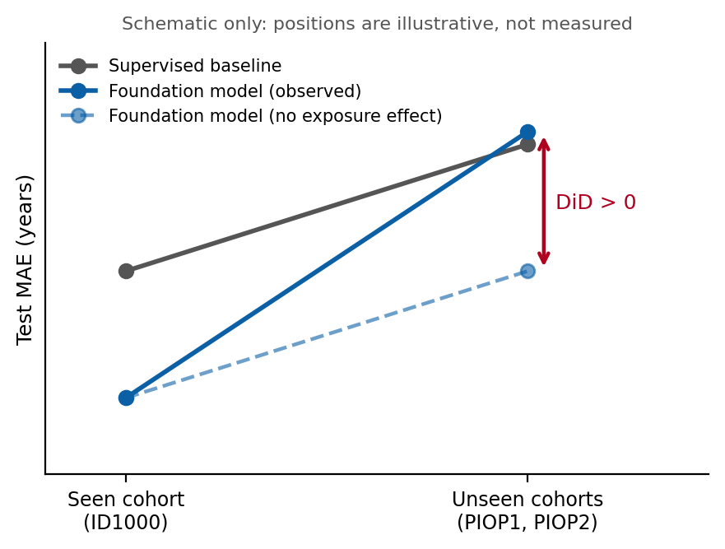
Label equivalence is given in Equation 14. Here N_base(N) is the number of labels the baseline needs to match the foundation model trained on N labels, and it is computed separately for the seen and unseen cohorts by curve fitting. Confidence intervals are 95% bootstrap intervals (Equation 15). The p-values are corrected across tasks T1 to T3 with the Holm–Bonferroni procedure [18] (Equation 16), where p_(j) are the sorted p-values and m is their number. The compute-matched Pareto frontier plots performance against logged GPU-seconds, and rank stability is the frequency of pairwise rank flips across seeds (Equation 17).
Eq. 14 — Label equivalence:
$$N_{eq}\left(N\right)=N_{base}\left(N\right)-N$$
Eq. 15 — Bootstrap confidence interval:
$${CI}_{95\%}=\left[Q_{0.025}\left(\{{DiD}^{\left(b\right)}\}_{b=1}^{2000}\right), Q_{0.975}\left(\{{DiD}^{\left(b\right)}\}_{b=1}^{2000}\right)\right]$$
Eq. 16 — Holm–Bonferroni adjusted p-value:
$${\tilde{p}}_{\left(k\right)}=\max_{j≤k} min\{1, \left(m-j+1\right) p_{\left(j\right)}\}$$
Eq. 17 — Rank-flip rate across seeds:
$$F\left(a,b\right)=\frac{1}{S}\sum_{s=1}^{S}{1}\left[sign\left({MAE}_{a}^{\left(s\right)}-{MAE}_{b}^{\left(s\right)}\right)≠sign\left({\overline{MAE}}_{a}-{\overline{MAE}}_{b}\right)\right]$$
The final system output reaches the evaluator in the form shown in Table V to Table VIII.
ALGORITHM 1: Subject-Level Contamination Audit
Algorithm 1: Contamination audit and cohort labelling
Input: Cohort ID sets {S_c}, manifest ID set P, thresholds τ_hi and τ_lo
Output: Overlap O(c) and status(c) for every cohort c
1. Load mapping.tsv and participants.tsv; build P from the subject identifiers
2. FOR each cohort c DO
3. Read the subject identifiers S_c from the cohort participants file
4. Normalise identifiers so that equivalent IDs compare equal
5. Compute |S_c ∩ P| and O(c) (Eq. 1)
6. IF O(c) ≥ τ_hi THEN status(c) ← seen
7. ELSE IF O(c) ≤ τ_lo THEN status(c) ← unseen
8. ELSE status(c) ← excluded
9. END FOR
10. Write the overlap table and figures; record the manifest version used
11. RETURN {O(c), status(c)}
ALGORITHM 2: Matched-Budget Evaluation and DiD
Algorithm 2: Matched-budget evaluation and difference-in-differences estimation
Input: Frozen splits for the seen and unseen cohorts; arms M; label budgets N; trial budgets T; seeds S
Output: Ledger rows; DiD, N_eq, Pareto frontier, rank-flip rate
1. Preprocess every volume with Pipeline B (Eq. 3, 4); cache as float16
2. FOR each cohort c in {seen, unseen} DO
3. FOR each arm m, budget N, trial budget T, seed s DO
4. Draw N labeled subjects from the training split of c using seed s
5. Run T Optuna trials; select λ* on validation MAE (Eq. 10)
6. Refit with λ*; log GPU-seconds (Eq. 11)
7. Append the cell result to results.parquet
8. END FOR
9. END FOR
10. Freeze the benchmark; evaluate each selected model once on its test split
11. Compute Δ_m (Eq. 12) and DiD (Eq. 13) for every FM–baseline pair
12. Bootstrap 2,000 resamples for the 95% CI and p (Eq. 15); apply Holm correction (Eq. 16)
13. Compute N_eq (Eq. 14), the Pareto frontier and F(a, b) (Eq. 17)
14. RETURN the statistics
IV. RESULTS AND DISCUSSION
All results are read from the append-only ledger (results.parquet) at benchmark freeze, with mock rows excluded. Tables V to VIII fix the reporting format. Cells marked TBD are filled in by the audit and analysis scripts named in each section, and nothing is entered by hand.
A. Experimental Setup
Every experiment runs through one harness. run_cell.py executes a single (task, model, N, seed, budget) cell, sweep.py runs the Optuna search [16], and ledger.py appends each result to results.parquet through a thread-safe, append-only writer. The baselines are built with MONAI [12] and LightGBM [15], while the foundation models are loaded from their released checkpoints [1], [2]. Each configuration is repeated with five seeds, and hyperparameters are chosen on validation folds only. We report the GPU model, driver and library versions (pinned in env/requirements.txt) alongside the ledger. A --mock mode exists purely to test the plumbing; its rows are tagged, and every analysis script excludes them. Table III and Table IV summarise the cohorts and the experimental factors.
TABLE III. Cohorts and Their Roles
Cohort | Role | Pretraining status
AOMIC ID1000 | T1 seen arm | Seen
AOMIC PIOP1 | T1 unseen arm | Unseen
AOMIC PIOP2 | T1 unseen arm | Unseen
IXI | T2 training cohort; audit | Seen
OASIS-1 | T3 and audit | Seen
OASIS-2 | Audit | Seen
Pretraining status is the pre-registered expectation; the audit in Section IV-C measures it.
TABLE IV. Experimental Factors
Factor | Levels
Task | T1 (AOMIC brain age), T2 (IXI to PIOP), T3 (OASIS dementia)
Cohort (T1) | Seen (ID1000); unseen (PIOP1, PIOP2)
Label budget N | 25, 50, 100, 250, 500, all
Optuna trials | 5, 20, 50
Seeds | 42, 1337, 2026, 7, 99
Primary metric (T1) | Mean absolute error (MAE), years

B. Dataset Description
The AOMIC releases contain 928 participants in ID1000, 216 in PIOP1 and 226 in PIOP2 [11]. After the 19.0 to 26.0 year age restriction and QC exclusions the analysed sizes are smaller, and the audit scripts report them. IXI [21] and OASIS [19], [20] enter the audit and tasks T2 and T3. Each AOMIC participant record includes age and sex, which we use for stratified splitting. The age window is narrow, so the target has low variance. For that reason a mean-age predictor appears as a reference row in every MAE table, to show the error floor.
C. Contamination Audit
Table V is the output of report_contamination.py. A cohort with overlap near 100% counts as seen, and one near 0% counts as unseen. Anything in between is reported, but that cohort is excluded from the seen-versus-unseen contrast.
TABLE V. Subject-Level Overlap Between Cohorts and the Pretraining Manifest
Cohort | Subjects | In manifest | O(c), %
AOMIC ID1000 | TBD | TBD | TBD
AOMIC PIOP1 | TBD | TBD | TBD
AOMIC PIOP2 | TBD | TBD | TBD
IXI | TBD | TBD | TBD
OASIS-1 | TBD | TBD | TBD
OASIS-2 | TBD | TBD | TBD

D. Brain-Age Error on Seen and Unseen Cohorts
Table VI gives test MAE for each arm at each label budget, with 95% bootstrap intervals over seeds. It is repeated for every N and every tuning budget, and the gap column is the quantity that feeds Equation 12.
TABLE VI. T1 Test MAE (Years) by Arm and Cohort, One Panel per N and Trial Budget
Arm | MAE seen | MAE unseen | Gap
Mean-age reference | TBD | TBD | TBD
ResNet-18 | TBD | TBD | TBD
DenseNet-121 | TBD | TBD | TBD
Volumetric + LightGBM | TBD | TBD | TBD
BrainIAC, tiers 1–4 | TBD | TBD | TBD
FOMO25, tiers 1–4 | TBD | TBD | TBD

E. Difference-in-Differences
Table VII holds the primary test of H1, produced by did.py. Each foundation-model arm is paired with the best-tuned baseline at the same N and the same trial budget.
TABLE VII. DiD Estimates (Years)
FM vs. baseline | DiD | 95% CI | p | Holm p
BrainIAC vs. ResNet-18 | TBD | TBD | TBD | TBD
BrainIAC vs. DenseNet-121 | TBD | TBD | TBD | TBD
BrainIAC vs. LightGBM | TBD | TBD | TBD | TBD
FOMO25 vs. ResNet-18 | TBD | TBD | TBD | TBD
FOMO25 vs. DenseNet-121 | TBD | TBD | TBD | TBD
FOMO25 vs. LightGBM | TBD | TBD | TBD | TBD

F. Label Equivalence, Compute and Rank Stability
Table VIII gives N_eq from label_equivalence.py. A large value on the seen cohort that shrinks on the unseen cohort would mean that the label-efficiency benefit depends on pretraining exposure. The compute-matched Pareto plot from pareto.py shows MAE against total GPU-seconds for each arm. Rank stability is reported as the share of seeds in which a pair of arms swaps order.
TABLE VIII. Label Equivalence N_eq by Label Budget
N | N_eq seen | N_eq unseen
25 | TBD | TBD
50 | TBD | TBD
100 | TBD | TBD
250 | TBD | TBD
500 | TBD | TBD

G. Ablation and Sensitivity Analyses
Five analyses test how robust the main contrast is. Table IX lists them along with the question each one answers.
TABLE IX. Planned Ablation and Sensitivity Analyses
Factor varied | Levels | Question
Adaptation tier | 1 to 4 | Does the exposure penalty grow with trainable capacity?
Tuning budget | 5, 20, 50 trials | Does more tuning close the baseline gap?
Label budget N | 25 to all | Is the penalty concentrated at low N?
Unseen cohort | PIOP1, PIOP2 | Is the unseen estimate stable across the two cohorts?
Seed | Five seeds | Are rankings stable?

H. Pre-Specified Interpretation of Outcomes
The reading of each possible outcome is fixed in advance, so the interpretation does not shift with what the data show (Table X).
TABLE X. Pre-Specified Interpretation of Outcomes
Outcome | Interpretation
DiD > 0, Holm p < 0.05 | H1 supported: part of the foundation-model advantage is attributable to pretraining exposure
DiD near 0, narrow CI | H0 not rejected: transfer consistent with no dependence on exposure
DiD near 0, wide CI | Inconclusive: the design lacks power to separate the two readings
DiD < 0 | The foundation model degrades less than the baseline on unseen subjects
N_eq large on seen, small on unseen | Label-efficiency claim holds only on exposed data
Frequent rank flips | Ranking of those arms at that N is not reliable

I. Discussion
The design is built so that either outcome tells us something. A positive DiD means part of a foundation model's reported advantage comes from having already met the evaluation subjects. It would also put benchmark results on OASIS, IXI and ID1000 in doubt for any model whose pretraining data include them. A DiD near zero with a narrow interval would be evidence that the learned representation transfers to unseen subjects from the same scanner and population, which is exactly the claim these models are built to support.
The secondary metrics ask whether the practical case for foundation models holds up under the same test. Label equivalence puts a number on the annotation savings, and the Pareto plot shows what those savings cost in GPU-seconds, tuning included. Suppose a model wins on seen data at low N but not on unseen data, or wins only at a compute cost far above a tuned ResNet-18 or a LightGBM model on regional volumes. Its case is then weaker than the headline numbers suggest.
The literature points the same way. Leakage inflates results when nobody looks for it [7], site and scanner effects can pass for model differences [8], and performance can drop on populations that were underrepresented in training [6]. Membership-inference work [9] adds that trained networks retain information about individual scans, so exposure to a test subject is not a harmless detail. For evaluators, the practical advice is to audit overlap with the pretraining manifest before picking a benchmark, report results separately for seen and unseen cohorts, give baselines the same preprocessing and tuning budget as the foundation model, and report compute next to accuracy.
J. Limitations
Several limitations need to be acknowledged. The pre-registration states that ID1000, PIOP1 and PIOP2 share scanner and protocol, but that claim should be checked against the AOMIC acquisition documentation, since cohorts collected in different periods can differ in more than the scanner. The DiD estimator also assumes that the baseline's seen-to-unseen gap is what the foundation model would show without exposure. An architecture that reacts differently to small cohort differences would bias the estimate, which is why we use several baselines and four adaptation tiers.
Contamination is model-specific. The audit uses the FOMO manifests, which describe the FOMO checkpoints, so BrainIAC's membership has to be established from its own documented pretraining data. The FOMO corpus has also come out at several sizes, for example FOMO50K and FOMO60K, which is why the audit must record the manifest version it used. We cannot retrain an encoder without ID1000 in this study, so a pretraining ablation is left to future work. Identifier matching can also miss overlap when the same person appears under a different identifier. Reported overlap is therefore a lower bound.
PIOP1 and PIOP2 together hold 442 participants before the age restriction and QC. That is below the largest fixed budget of N = 500, and the held-out test split shrinks the training pool even more, so the affected budgets and the meaning of “all” on each cohort need explicit handling in the task configuration. Restricting to 19 to 26 years lowers the variance of the target, which makes MAE differences small against the mean-predictor floor. Finally, brain-age regression is the only task with the same-scanner contrast. T2 and T3 broaden the audit, but they do not share that control.
V. CONCLUSION AND FUTURE WORK
This paper presented a contamination-audited, label-budget-matched evaluation of 3D brain-MRI foundation models. The evaluation brings together a subject-level overlap audit, a pre-registered difference-in-differences contrast on the Amsterdam Open MRI Collection, tuned supervised baselines under matched budgets, and a ledger-based analysis of label equivalence, compute and rank stability. Because hypotheses, controls and decision rules are fixed before training, the result can be read as evidence and not as a hunt for a favourable benchmark.
Several directions look worth pursuing next. Pretraining ablations that remove the seen cohort would turn the natural experiment into a controlled one. Scan-level overlap checks would complement identifier matching and tighten the lower bound on contamination. Unseen cohorts from other scanners would show whether the penalty depends on the scanner, and membership-inference tests [9] could give an independent signal of exposure. The most direct route to evidence that matters for deployment is to extend the same-scanner contrast beyond brain-age regression to the clinical tasks used in the foundation-model papers [1], [2].
VI. DATASET
The evaluation cohorts are publicly available. The AOMIC collection [11] is hosted on OpenNeuro: ID1000 https://openneuro.org/datasets/ds003097, PIOP1 https://openneuro.org/datasets/ds002785 and PIOP2 https://openneuro.org/datasets/ds002790.
The pretraining manifests come from the FOMO60K release [3] https://arxiv.org/abs/2506.14432. The audit also uses IXI [21] https://brain-development.org/ixi-dataset/ and OASIS [19], [20] https://www.oasis-brains.org/. Each AOMIC participant record includes age, biological sex and acquisition information, and these fields support the stratified splitting and the QC logging described in Module 2.
REFERENCES
[1] D. Tak et al., “A foundation model for generalized brain MRI analysis,” Nature Neuroscience, 2026. DOI: 10.1038/s41593-026-02202-6
[2] A. Munk et al., “Towards brain MRI foundation models for the clinic: Findings from the FOMO25 challenge,” arXiv:2604.11679, 2026.
[3] A. Munk et al., “A large-scale heterogeneous 3D magnetic resonance brain imaging dataset for self-supervised learning,” arXiv:2506.14432, 2025.
[4] J. Cox et al., “BrainSegFounder: Towards 3D foundation models for neuroimage segmentation,” Medical Image Analysis, Art. no. 103301, 2024. DOI: 10.1016/j.media.2024.103301
[5] M. Mazher, G. J. M. Parker, and D. C. Alexander, “Towards generalisable foundation models for 3D brain MRI,” arXiv:2510.23415, 2025.
[6] O. I. Akinmuleya, O. S. Akano, S. D. Ankapong, O. Lawal, and T. Musah, “Evaluating the generalization of neuroimaging foundation models on African brain MRI,” arXiv:2609.23983, 2026.
[7] M. Rosenblatt, L. Tejavibulya, R. Jiang, S. Noble, and D. Scheinost, “Data leakage inflates prediction performance in connectome-based machine learning models,” Nature Communications, vol. 15, 2024. DOI: 10.1038/s41467-024-46150-w
[8] A. Solanes et al., “Removing the effects of the site in brain imaging machine-learning – Measurement and extendable benchmark,” NeuroImage, 2023.
[9] U. Gupta, D. Stripelis, P. K. Lam, P. M. Thompson, J. L. Ambite, and G. Ver Steeg, “Membership inference attacks on deep regression models for neuroimaging,” in Proc. Medical Imaging with Deep Learning (MIDL), PMLR vol. 143, 2021.
[10] W. Li et al., “Privacy-preserving federated brain tumour segmentation,” in Proc. Machine Learning in Medical Imaging (MLMI), 2019. arXiv:1910.00962
[11] L. Snoek, M. M. van der Miesen, T. Beemsterboer, A. van der Leij, A. Eigenhuis, and H. S. Scholte, “The Amsterdam Open MRI Collection, a set of multimodal MRI datasets for individual difference analyses,” Scientific Data, vol. 8, Art. no. 85, 2021.
[12] M. J. Cardoso et al., “MONAI: An open-source framework for deep learning in healthcare,” arXiv:2211.02701, 2022.
[13] K. He, X. Zhang, S. Ren, and J. Sun, “Deep residual learning for image recognition,” in Proc. IEEE Conf. Computer Vision and Pattern Recognition (CVPR), 2016, pp. 770–778.
[14] G. Huang, Z. Liu, L. van der Maaten, and K. Q. Weinberger, “Densely connected convolutional networks,” in Proc. IEEE Conf. Computer Vision and Pattern Recognition (CVPR), 2017, pp. 4700–4708.
[15] G. Ke et al., “LightGBM: A highly efficient gradient boosting decision tree,” in Proc. Advances in Neural Information Processing Systems (NeurIPS), vol. 30, 2017, pp. 3146–3154.
[16] T. Akiba, S. Sano, T. Yanase, T. Ohta, and M. Koyama, “Optuna: A next-generation hyperparameter optimization framework,” in Proc. 25th ACM SIGKDD Int. Conf. Knowledge Discovery and Data Mining, 2019, pp. 2623–2631.
[17] D. Card and A. B. Krueger, “Minimum wages and employment: A case study of the fast-food industry in New Jersey and Pennsylvania,” American Economic Review, vol. 84, no. 4, pp. 772–793, 1994.
[18] S. Holm, “A simple sequentially rejective multiple test procedure,” Scandinavian Journal of Statistics, vol. 6, no. 2, pp. 65–70, 1979.
[19] D. S. Marcus, T. H. Wang, J. Parker, J. G. Csernansky, J. C. Morris, and R. L. Buckner, “Open Access Series of Imaging Studies (OASIS): Cross-sectional MRI data in young, middle aged, nondemented, and demented older adults,” Journal of Cognitive Neuroscience, vol. 19, no. 9, pp. 1498–1507, 2007.
[20] D. S. Marcus, A. F. Fotenos, J. G. Csernansky, J. C. Morris, and R. L. Buckner, “Open Access Series of Imaging Studies: Longitudinal MRI data in nondemented and demented older adults,” Journal of Cognitive Neuroscience, vol. 22, no. 12, pp. 2677–2684, 2010.
[21] “IXI dataset,” Biomedical Image Analysis Group, Imperial College London. [Online]. Available: https://brain-development.org/ixi-dataset/
GITHUB LINK: https://github.com/Pranav-PN/brain-MRI-contamination-audit

